**Github Wiki**

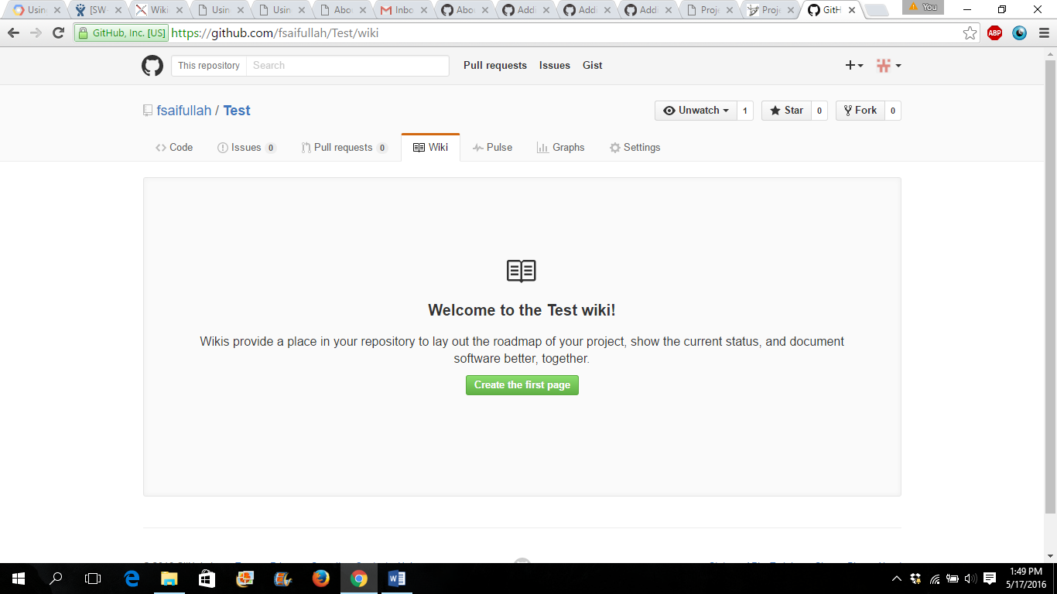

Problems/Issues: GitHub Wiki seems to allow only one set of headers – False, but I need to find the bug

Issue Solved-You can NOT have a space between the list and the heading and have multiple headings

Ex: # Testing wiki for Github.

## Steps to create

1.Useless info

##Test Headings

#Test Headings

1. Space taking up

2. Space taking up

3. Space taking up

###Test Headings



Vs.

# Testing wiki for Github.

## Steps to create

1.Useless info

##Test Headings

#Test Headings

1.Space taking up

2.Space taking up

3.Space taking up

###Test Headings

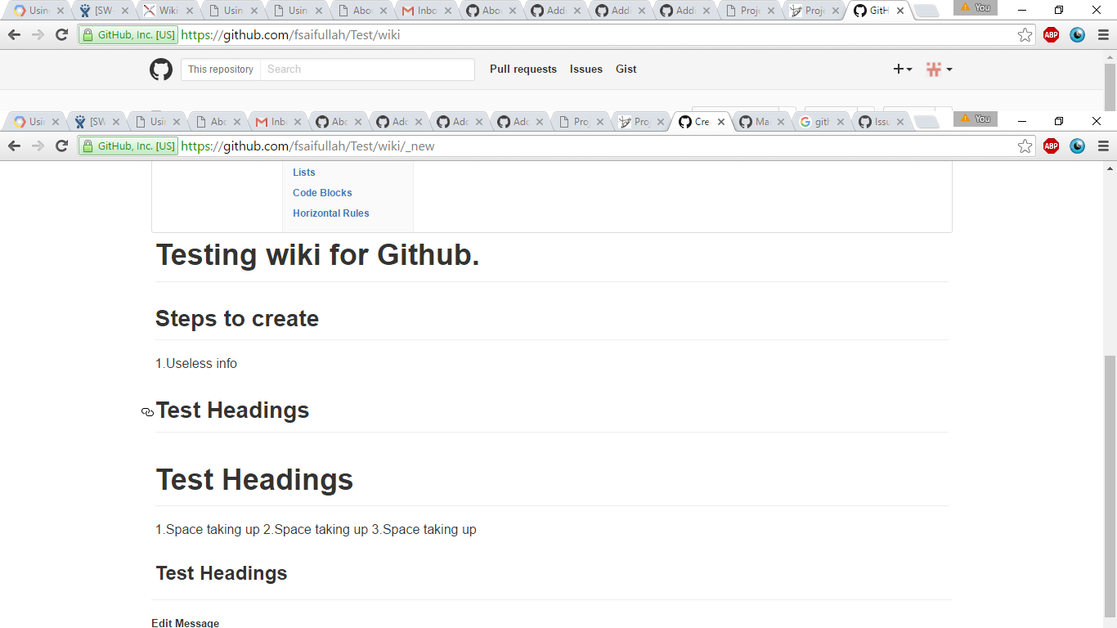

Images: Click on Images, copy down Image URL, then Post that Image URL in the Image URL box.

Links: Format is [Title] (Link URL)

Videos: They are added the same way as Links

Code: There is a code button on the Wiki, but the syntax is ‘Code’

Pros: Easy to use

Cons: Don’t know how to share yet, You can get onto Github on a smartphone, you just have to switch from the mobile version of the website to the desktop version

Search: Use a search toolbar, however repositories need to be shared with whoever wants to see it.

**Confluence**: Not wiki, but they use spaces. Spaces are repositories essentially. 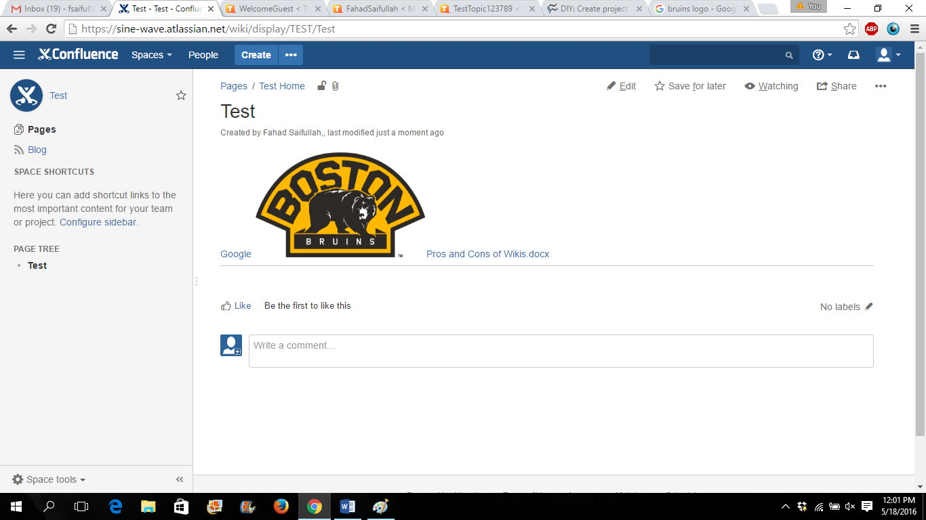

Pros: Attaching files is a lot easier w/ Confluence. There is no wiki though

Cons: Also I am not sure if there is editing of spaces. Need to check that as well

Links: You have to specify which space the link will be in before you can do the link

Search: Searching is very easy using a search toolbar.

Goal: To find out which one can be better organized and easier to extract files from

**Project Forum**: Bad, script error when downloading; Price Range: Free: one group, unlimited users, essential wiki features

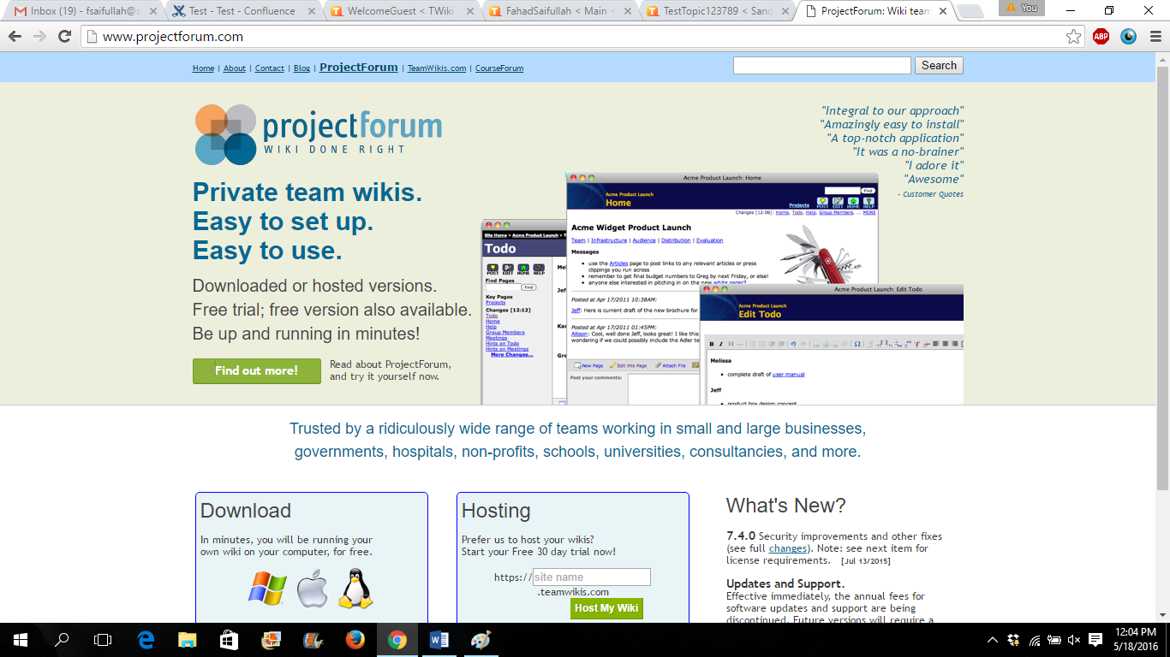

Basic: one group, unlimited users, essential features + extras. $79

Standard: multiple wikis, unlimited users, full range of features. $249/one group, $599/five groups, $849/10 groups, $1,799/50 groups

Enterprise: unlimited wikis >= 150 users, full range of features + extra access controls. Pricing starts at $1,000

Features: Can set up Wikis for groups. Site, group, project administrators; Shared password for all users or individual accounts; Page locking; Activity tracking; Version control; SSL encryption; Branding; Templates; Custom links; Web views; Simple WYSIWYG editor; Image and file attachments; Changes reported via email; Comments NOT TESTED

**Media Wiki**: Bad, downloading it is a pain. You need to download a zipped folder, extract it to a datapath, open up Microsoft Edge and write the data path into the Web browser. From the reviews I read, the syntax is kind of difficult to learn. Media Wiki uses Wikipedia’s interface. <https://www.youtube.com/watch?v=F8irbbwNo2E>

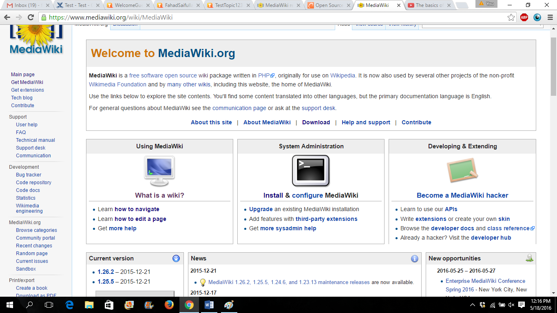

**TWiki**: Completely Open Source, Writing a Wiki is the same way that you write a page in Conflue nce. Easy to Search wikis once made. You can create a tag for a project so all wikis can be grouped with that specific project.

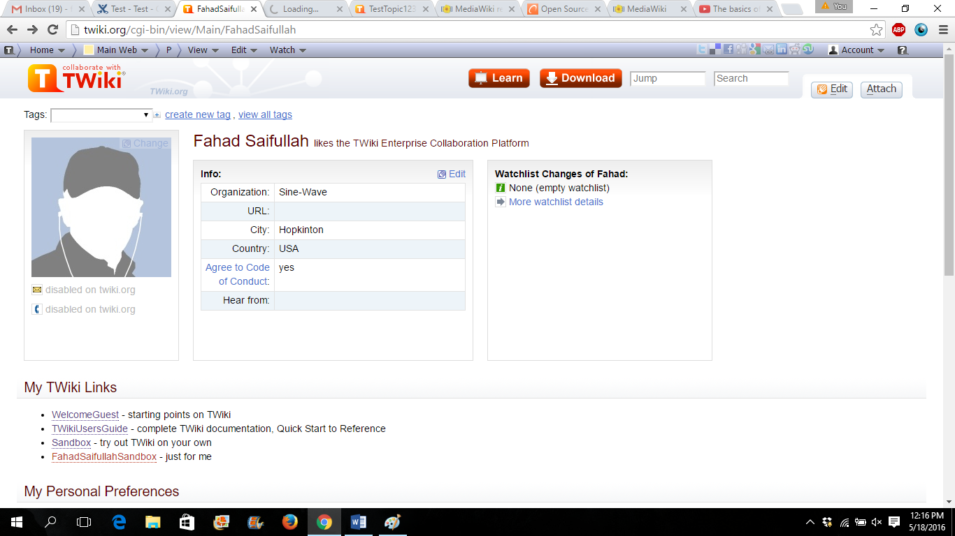

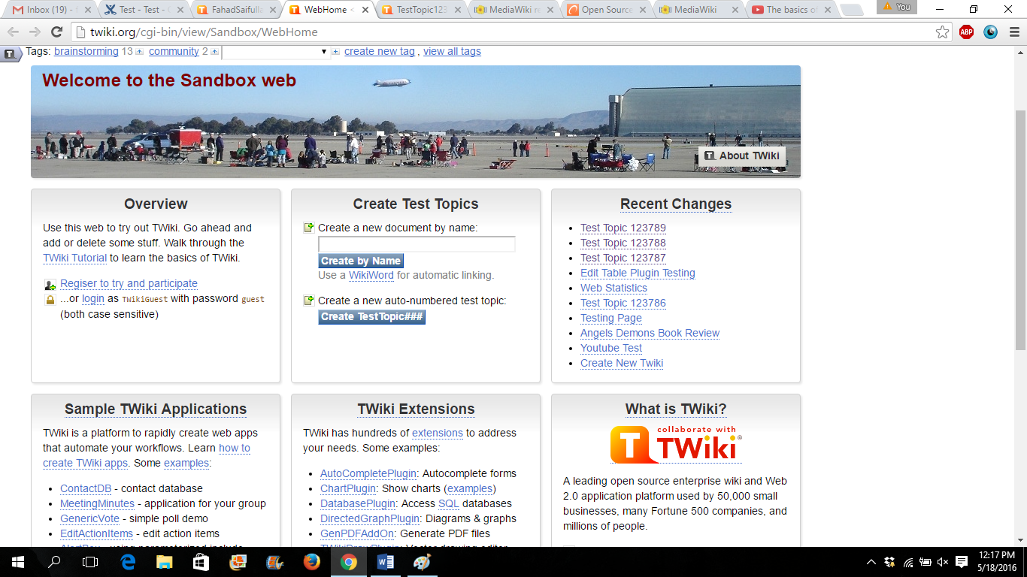

Cons: While Confluence and Github are already there, TWiki would have to be downloaded by everyone. I am not fully used to the syntax yet so I would need some more time to work with it before I could teach it.

**Zoho Wiki**: Wiki Software. Paid, Can be OpenSource, personal, or between a select group. Syntax is like Microsoft Word, with the option of adding attachments.

Cons: HTML sometimes does not work.



<http://www.wikimatrix.org/compare/Confluence+Git-Wiki+MediaWiki+ProjectForum+TWiki+Zoho-Wiki>